**DAILY ONLINE ACTIVITIES SUMMARY**

|  |  |  |  |  |  |  |
| --- | --- | --- | --- | --- | --- | --- |
| **Date:** | | **13 June 2020** | | **Name:** | **KHATHEEJA SAFREENA** | |
| **Sem & Sec** | | **4th sem, 2nd year** | | **USN:** | **4AL18CS036** | |
| **Online Test Summary** | | | | | | |
| **Subject** | **DATA COMMUNICATION (18cs46)** | | | | | |
| **Max. Marks** | **30** | | **Score** | | **25** | |
| **Certification Course Summary** | | | | | | |
| **Course** | | **Introduction to cyber security.** | | | | |
| **Certificate Provider** | | **GreatLearning** | **Duration** | | | **6 hours** |
| **Coding Challenges** | | | | | | |
| **Problem Statement:1 program** | | | | | | |
| **Status: Executed** | | | | | | |
| **Uploaded the report in Github** | | | **Yes** | | | |
| **If yes Repository name** | | | [http://shafreenasharief / lockdown-coding](http://shafreenasharief / lockdown-coding" \o "http://shafreenasharief / lockdown-coding)  [http://shafreenasharief / locked-down--certification-course](http://shafreenasharief / locked-down--certification-course" \o "http://shafreenasharief / locked-down--certification-course)  [http://shafreenasharief / Daily\_Report](http://shafreenasharief / Daily_Report" \o "http://shafreenasharief / Daily_Report) | | | |
| **Uploaded the report in slack** | | | **Yes** | | | |

Online Test Details: (Attach the snapshot and briefly write the report for the same)

Certification Course Details: (Attach the snapshot and briefly write the report for the same)

Coding Challenges Details: (Attach the snapshot and briefly write the report for the same)

**ONLINE TEST SUMMARY**

Today test has be conduct on  **DATA COMMUNICATION (18cs46)** for 30marks with duration of 30 minutes.

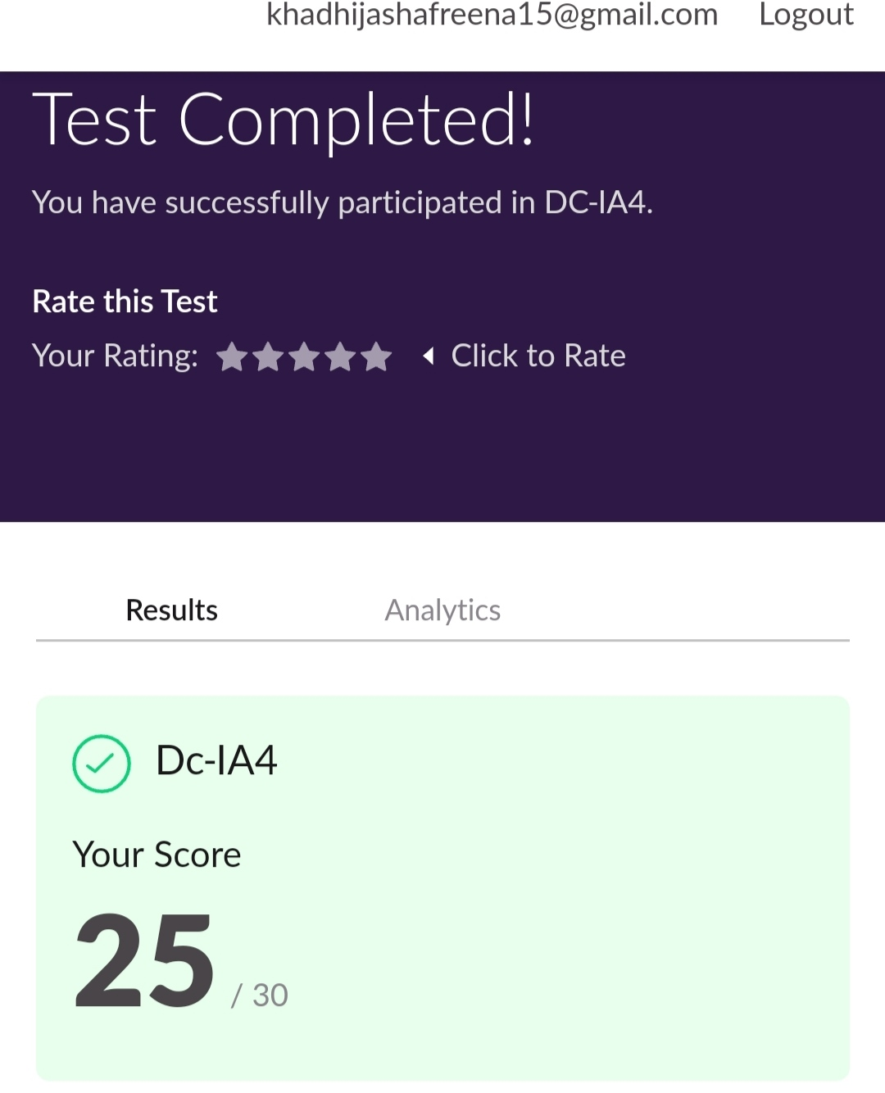

**CERTIFICATION COURSE SUMMARY:**

Today I started new course **INTRODUCTION TO CYBER SECURITY** through **GREAT LEARNING** the course is secluded for 6hrs**.** After the completion of course, certificate will be provided. I completed all the module .I attempted quiz ,which gave me a clear veiw about the topics that were thought and discussed.It consists of 7 modules which also include assessments.



**CODING CHALLENGES:**

Today I solved coding challenge,

**1.** **How to find the first non-repeated character of a given String?**

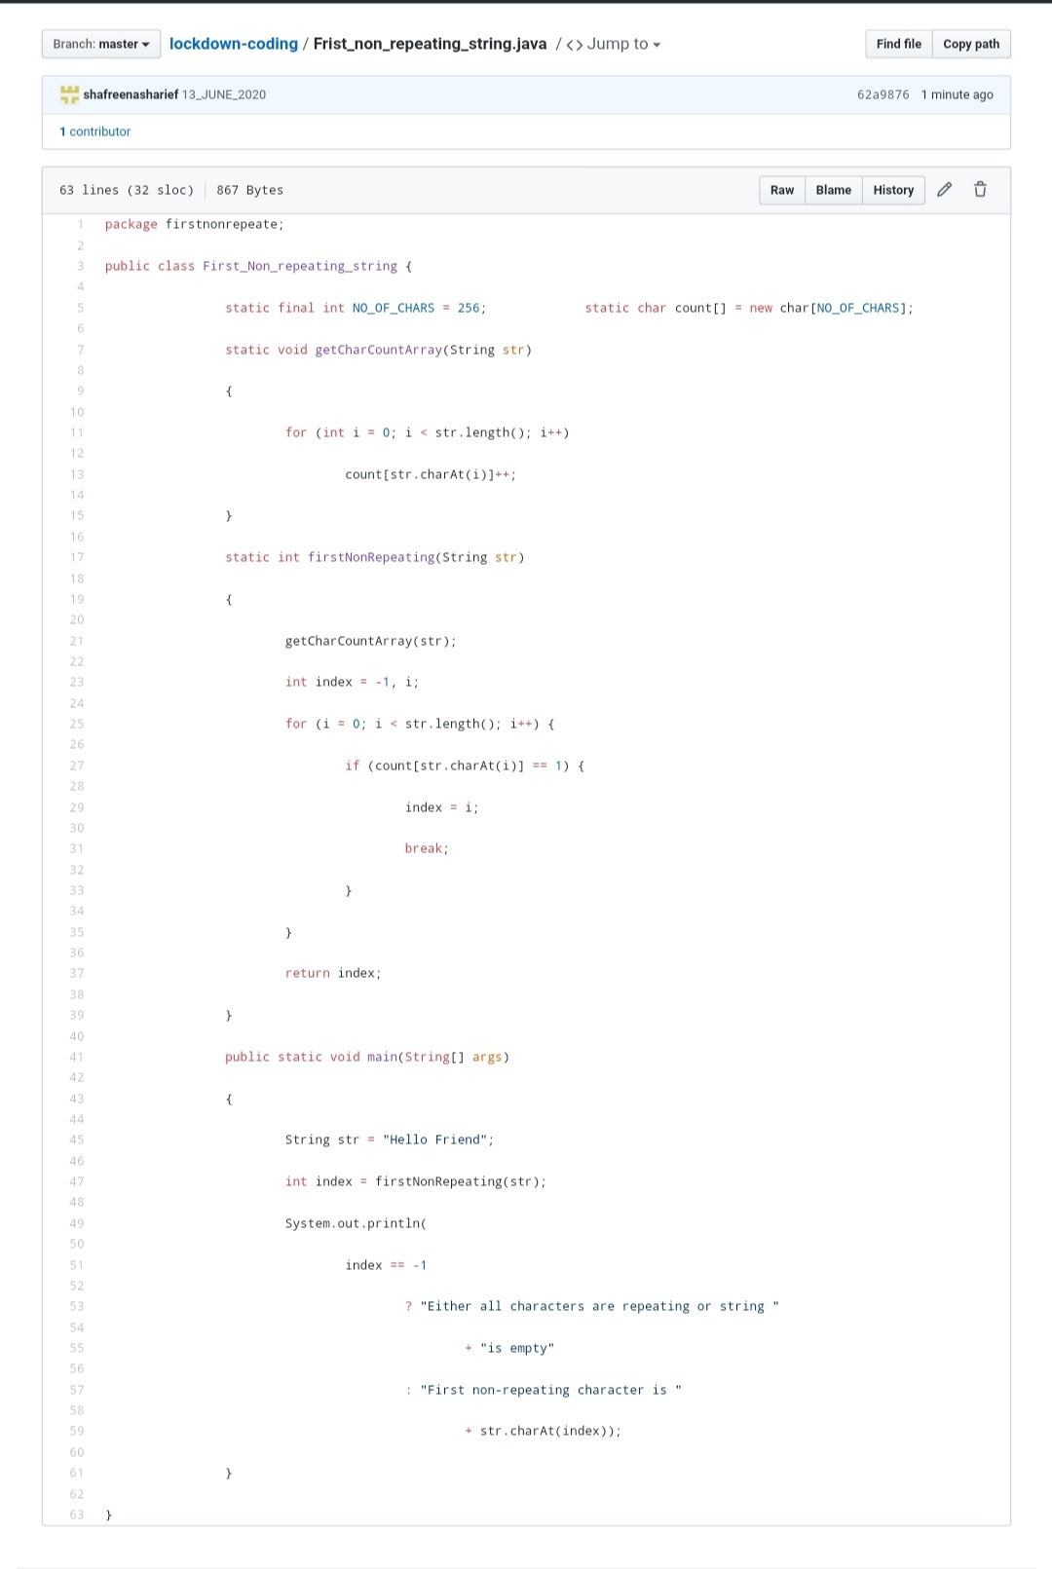

**EXTRA ACTIVITIES:**

I attended **E-Quiz on OPERATING SYSTEM** Organized by MOODLAKATTE INSTITUTE OF TECHNOLOGY which was conducted on 11/6/2020 securing 100% . The e-certificate is been provide on 13/06/2020.

* **There is the snapshot of the e-certificate.**



SOLUTION : I have uploaded the solution of the above 3 coding problems in my GitHub repository.

[http://shafreenasharief / lockdown-coding](http://shafreenasharief / lockdown-coding" \o "http://shafreenasharief / lockdown-coding)

[http://shafreenasharief / locked-down--certification-course](http://shafreenasharief / locked-down--certification-course" \o "http://shafreenasharief / locked-down--certification-course)

[http://shafreenasharief / Daily\_Report](http://shafreenasharief / Daily_Report" \o "http://shafreenasharief / Daily_Report)